# Game Design – Final Project Template

***This is a skeleton outline for a game design. Your design may be more than one page!***

High Level Concept/Design

## (Module 3) Working title:

*Keepy-Uppy*

## (Module 3) Concept statement:

*Skill based game that pairs reaction speed and hand-eye coordination by drawing lines to prevent the ball from getting to the bottom of the screen.*

## (Module 3) Player experience and game POV:

*The game consists of one level the progressively gets harder. The player views the playing field from the side and watches as a ball falls from the top of the screen. The player draws lines below the ball to prevent it from hitting the bottom of the screen. The ball bounces off the line and deletes it, forcing the player to keep drawing lines to keep the ball up.*

## (Module 3) Genre(s):

Product Design

*This is an action game.*

## (Module 7) Visual/audio Style:

*What is the “look and feel” of the game? How does this support the desired player’s experience?*

## (Module 3) Platform(s) and primary technology:

*~~The target platform for this game is both PC and mobile and will be created using Unity.~~*

*The target platform for this game is PC and will be created using Unity.*

## (Module 3) Schedule and scope

*Week 1 – Nov 5: Create core design document, begin core gameplay loop.*

*Week 2 – Nov 12: Finish core gameplay loop, add sound, begin difficulty progression.*

*Week 3 – Nov 19: Finish difficulty progression, begin UI and Upgrade mechanics.*

*Week 4 – Nov 26: Finish UI and Upgrade mechanics, begin UI customization options.*

*Week 5 – Dec 3: Finish UI customization options, begin polish and bug fixes.*

*Week 6 – Dec 10: finish polish and publish.*

## (Module 4) Game world fiction:

*This game has no narrative.*

## (Module 6) Objectives and Progression

Detailed Game Design

*The player will be greeted by a “Welcome” screen that has a “Play” button as the largest button on top, then an “Upgrades” button and an “Options” button.*

*Upon pressing “Play”, the game starts where a ball will drop, and the player will click and drag on the play area to create a line. When the ball hits the line, the line will disappear. The player will be limited to one line initially, with plans to have upgrades to allow more lines to be drawn at the same time. Once the player loses all their lives, a “Game Over” screen will appear with the same options as the “Welcome” screen.*

*The “Upgrades” button will open a menu with different selections where the player can purchase upgrades to make the game easier, such as lowering the final speed limit of the ball, being able to place multiple lines, and purchasing and upgrading a shield at the bottom of the screen to save the player if they miss the ball.*

*The “Options” menu will allow players to turn the sound on or off. If development time allows, I plan on having different customization options where the player can change the background, ball sprite, and line sprite.*

## (Module 6) Interactivity

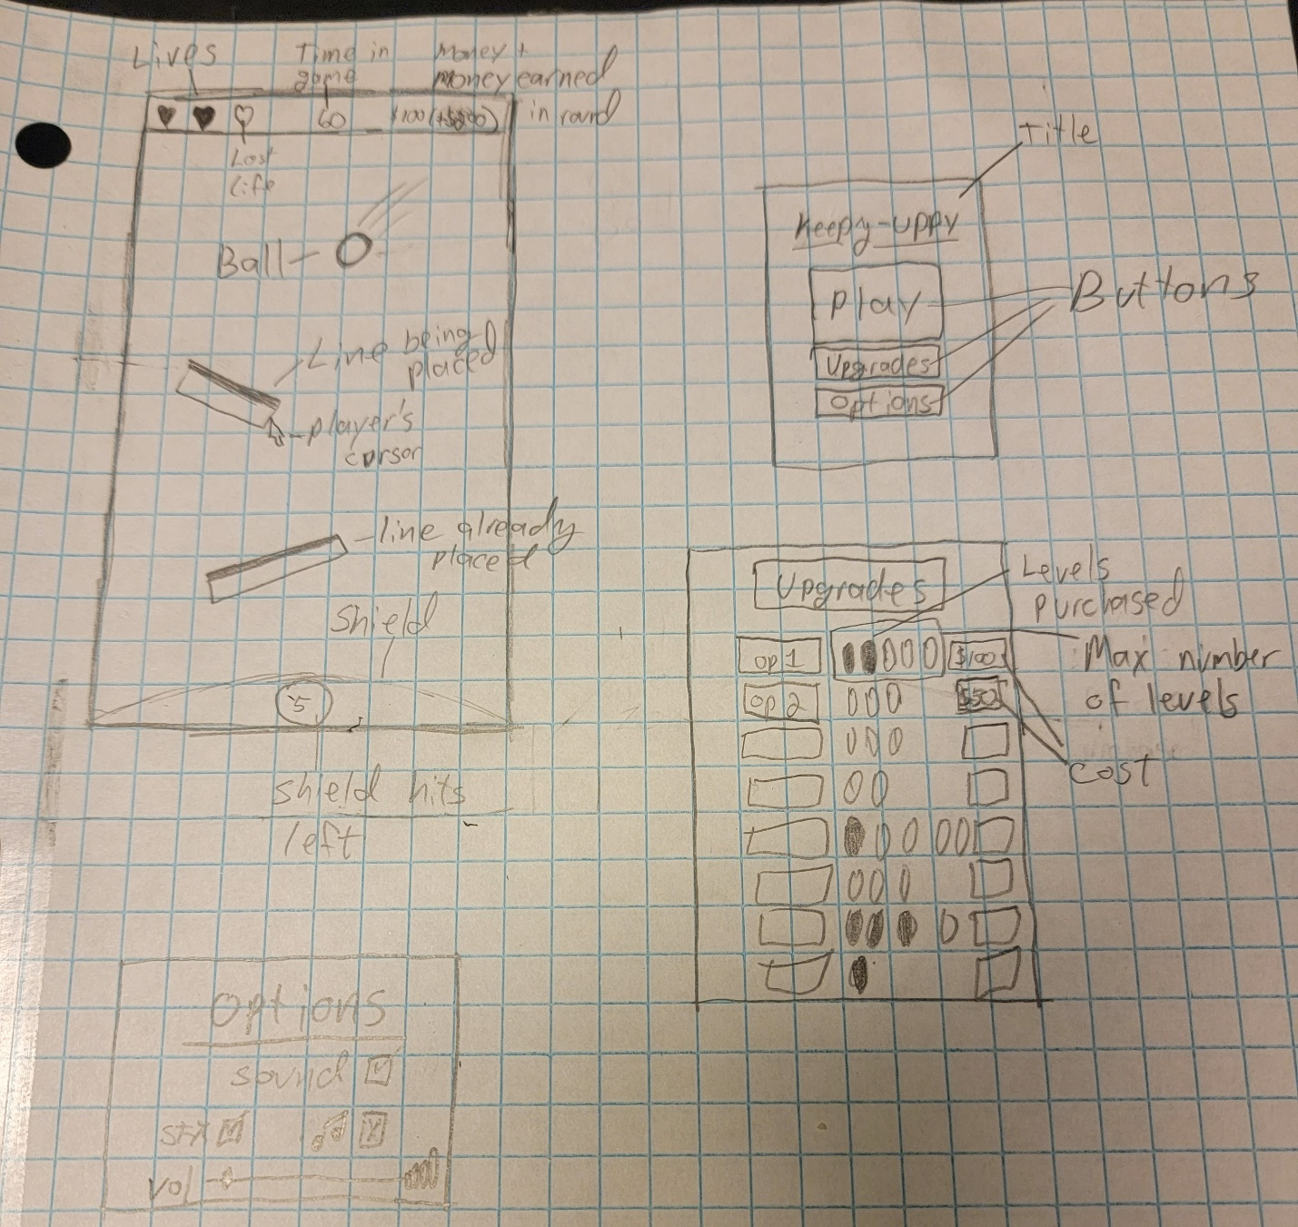

## (Module 4) Internal structure

* *Ball*
  + *Spawns from random location at top of screen*
  + *Affected by gravity*
  + *Has 1.2 bounciness physics material*
  + *Destroyed at bottom of screen*
    - *spawns particle effect where death occurred*
    - *waits 2 seconds, then spawns another ball.*
  + *Sounds:*
    - *Instantiated: pop sound*
    - *~~- y-Velocity past threshold (TBD): falling noise~~*
    - *Bounces: boing*
      * *Destroyed: Crash if player has lives left, else womp womp*
* *Line*
  + *Created where player clicks mouse button 1 or taps*
  + *Stretches and rotates while player keeps mouse button 1 or finger held down*
  + *When player lifts mouse button 1 or finger, it activates the collider and sets its bounds to match the line.*
  + *Not affected by gravity*
  + *Deleted when ball hits*
  + *Each line has a max length. Starts at (TBD) and can be upgraded to (TBD)*
  + *Limited to 1 line initially, but can be upgraded to 4.*
* *~~Power-ups~~*
  + *~~Spawn randomly in top 75% of play area~~*
  + *~~Will activate when ball hits it~~*
  + *~~Activates at random intervals between 10 and 30 seconds~~*
    - *~~Can be upgraded to shorten intervals~~*
      * *~~-1 to lower bound~~*
      * *~~-4 to upper bound~~*
      * *~~Down to between 5 and 10 seconds~~*
  + *~~Powerup categories~~*
    - *~~Split~~*
      * *~~Symbol: 3 balls in a triangle~~*
      * *~~Effect: sends 3 additional balls flying straight up, and 45 degrees to the right and left at a set velocity (TBD)~~*
      * *~~Sound: 3 pops, created when ball gets instantiated, not by power-up~~*
    - *~~Slow~~*
      * *~~Reduces velocity of all balls by half for 10 seconds~~*
    - *~~Shield~~*
      * *~~Creates a curved shield at the bottom of the screen with a number showing in the center~~*
      * *~~The number is how many hits it can take before it disappears~~*
      * *~~Starts at 1, can be upgraded to 10~~*
    - *~~Extra life~~*
      * *~~Rare power-up~~*
      * *~~Grants one more life~~*
    - *~~Extra money~~*
      * *~~Grants +$10~~*
    - *~~Bombs~~*
      * *~~Spawns at a random location~~*
        + *~~Below ball if y-velocity is positive~~*
        + *~~Above ball if y-velocity is negative~~*
      * *~~15 second life-span (can be shortened to 5 seconds)~~*
        + *~~Will destroy itself upon hitting life-span~~*
* *Lives*
  + *Non-interactable*
  + *Top-left overlay*
  + *Shows how many lives player has remaining*
* *Timer*
  + *Non-interactable*
  + *Top-middle overlay*
  + *Show how long the player has survived*
  + *Starts at 0 each playthrough and counts up*
* *Money*
  + *Non-interactable*
  + *Top-right overlay*
  + *Shows how much money player has and how much the player will earn upon defeat in the format*
    - *$ has (+$will earn) – ex. $50 (+$35)*
  + *Money is used to purchase upgrades on main screen.*
  + *Money is earned*
    - *~~+$1 per 1 second (can be upgraded to 2, in increments of .1)~~*
    - *~~+$5 per bounce on line~~*
    - *~~+$10 per ‘extra money’ powerup~~*

## (Module 4) Core loops

* *Main gameplay loop:*
  + *Player will start the game with a blank scene that has an overlay of their Lives, a timer, and their money (currently at 0)*
  + *After 2 seconds, a ball will fall and the game will start.*
  + *Player will click/tap and drag to draw lines to try and keep the ball from hitting the bottom of the screen.*
  + *When the last ball hits the bottom of the screen, a life is lost*
  + *Once all lives are lost, it will display a summary of the session, how much money the player earned, and the option to play again, or upgrade*
  + *On the upgrade screen, user can choose to upgrade different options (if they have enough money), and then play again.*
* *Macro scope:*
  + *Get the highest score they can*
* *Intermediate scope:*
  + *Earn money to buy upgrades*
* *Micro scope:*
  + *Stop the ball from hitting the bottom*
  + *Try to bounce the ball into powerups and away from bombs*
* *Main feedback loop:*
  + *Positive*
    - *Player earns money based on time played and how many times the ball was bounced*
    - *Player can use this money to buy upgrades to make the game easier*
  + *Negative*
    - *As the player plays longer, the ball’s size gets smaller to a limit*
    - *Once the limit is hit, the ball’s max speed slowly increases to a limit.*
    - *Once both limits are hit, bombs become more likely to spawn*
* *Why is this engaging?*
  + *Players must react quickly to the angle of the ball and make sure where they’re creating the line is close enough to the path of the ball that it can reach it.*
  + *This plays on the “easy to learn, hard to master” principal.*